2.1 Adding integers

The temperature last night was –3 degrees.
This morning it has increased by 5 degrees. What is the temperature?
To calculate the answer we need to add –3 and 5.
To add positive and negative numbers, refer to a number line.
To add a positive number, move to the right.
To add a negative number, move to the left.
–3 + 5To add –3 and 5, start at –3 on the number line.
Count 5 places to the right (the positive direction).

The answer is 2, so –3 + 5 = 2
4 + (–2)To add 4 and –2, start at 4 on the number line.
Count 2 places to the left (the negative direction).

The answer is 2, so 4 + (–2) = 2
Note that 4 + (–2) is the same as 4 – 2.
EXAMPLES

1 Complete these additions.
You can use the number line at the top of this page to help.
a 3 + 4 = ___________ b –3 + 7 = ___________ c –4 + 3 = __________
d 6 + (–3) = _________ e 2 + (–5) = __________ f 4 + (–7) = _________
g –2 + 5 = __________ h –1 + (–4) = _________ i –2 + (–6) = ________
j –4 + (–3) = ________ k –3 + 8 = ___________ l 0 + (–5) = _________
m –7 + (–4) = ________ n 7 + (–6) = __________ o –8 + (–3) = ________
p –5 + 10 = _________ q 5 + (–12) = _________ r 7 + (–9) = _________
s –9 + 0 = __________ t –5 + (–5) = _________ u 8 + (–8) = _________
v –7 + 9 = __________ w 8 + (–9) = __________ x –4 + (–7) = ________
2.1 Adding integers
continued
2 The overnight temperature was –2°C.
By midday it had risen 10°C.
What was the temperature at midday? ___________
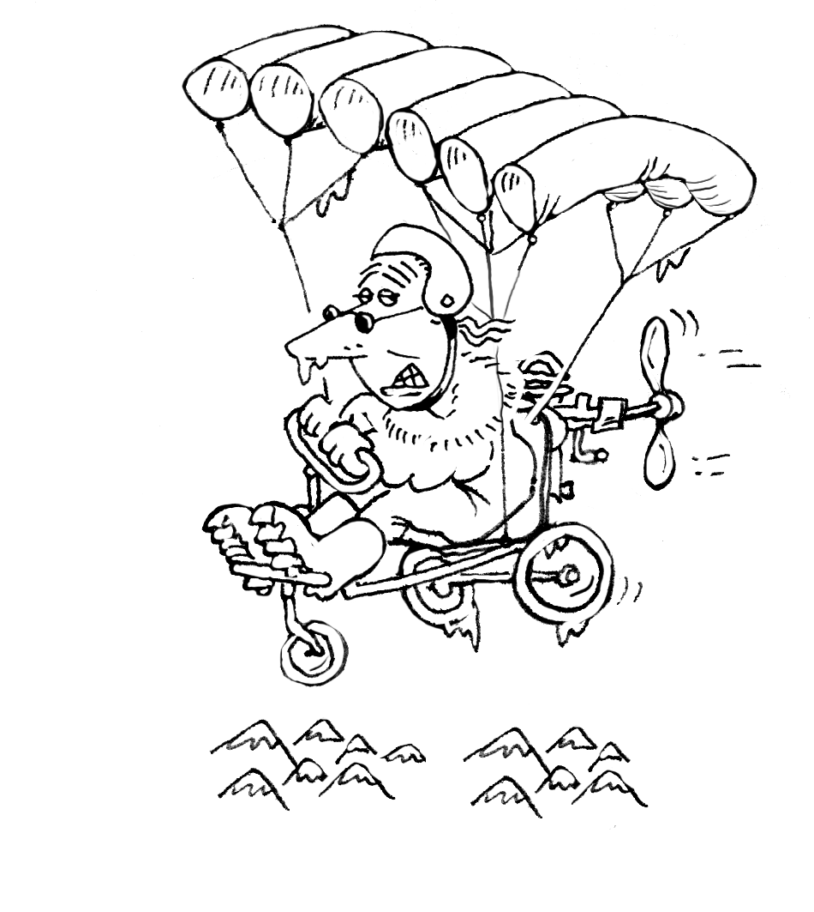
3 Emily walked 6 kilometres east.
She then walked 9 kilometres west.
How far is Emily from her starting point? ___________
4 Joe’s bank statement showed a balance of –$355.
He owed the bank $355. He made a deposit of $240.
What is the new balance? _____________
5 In a quiz, contestants score 1 point for a correct answer. They lose 2 points for each wrong answer. Kurt’s answers for ten questions were:
correct, correct, wrong, wrong, correct, correct, correct, wrong, correct, correct.
a Write Kurt’s score for each question. __________________________________
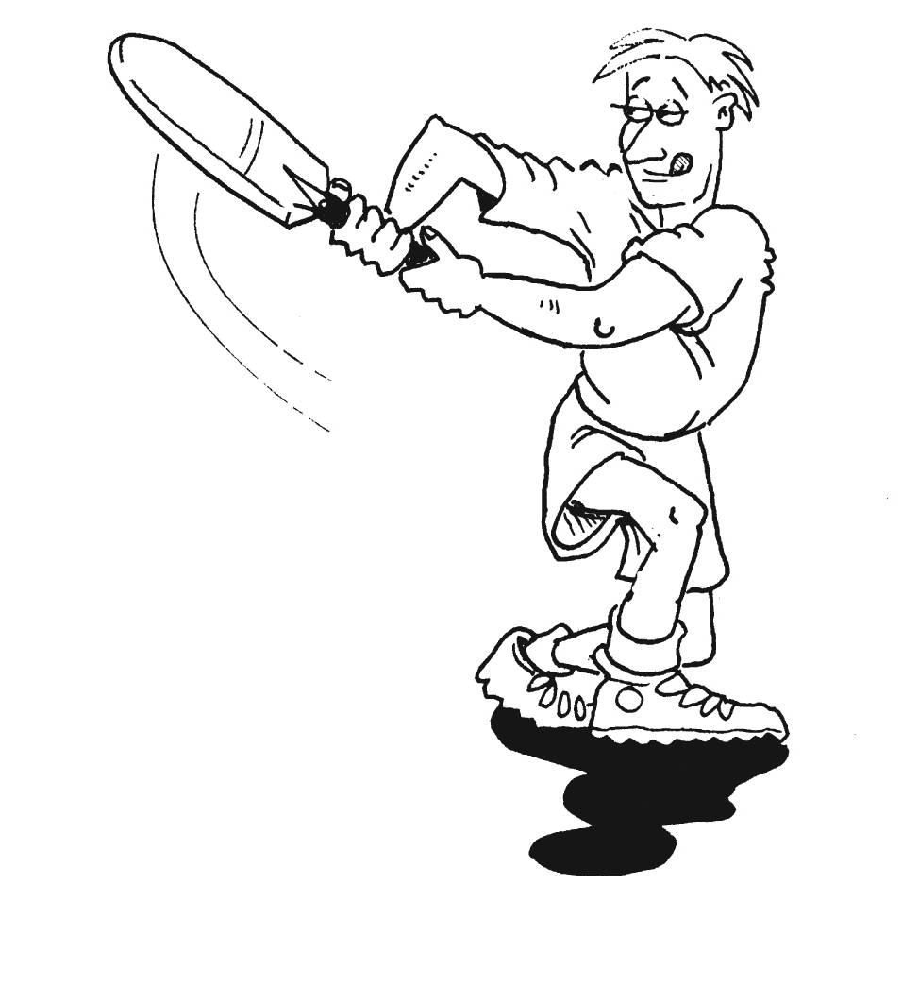
b What was Kurt’s total score for the quiz? ____________
6 On five consecutive balls in indoor cricket, Bryan scored:
2 runs, 1 run, 6 runs, run out (lose 5 runs), 2 runs.
What was his total score from these five balls? ____________
7 Positive and negative numbers are often used to keep score
in a game of golf. Kate had these scores on nine holes:
par (0), bogey (+1), birdie (–1), par (0), bogey (+1), eagle (–2),
par (0), birdie (–1), albatross (–3).
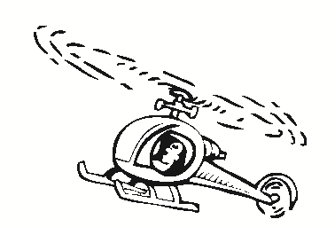
What is her total score? ______________
8 A helicopter is flying over a valley.
It rises 30 metres to fly over some trees.
It then falls 50 metres, rises 25 metres,
falls 10 metres and rises 40 metres.
How far is the helicopter above or below its original position? ________________
9 Michael has a savings account.
He made the following transactions during the past month:
deposit $236, withdraw $415, deposit $165, deposit $284, withdraw $326.
How had his balance changed at the end of the month? __________________

